Web data extraction Requirement document

Suggested Code Policy:

1. Copy the Project folder structure from bellow github link.

<https://github.com/hackathonScrapping/BANK.git>

1. Use Python(Mandatory) with BeautifulSoup, Scrapy and Selenium (Feel free to use any other Python libraries)
2. Store Scrapped data with provided file name and CSV format.

Work 1:

**Scarped Data Format (File Name - Sync_Data_Deposit_<MM_DD_YYYY>.csv)**

|  |  |  |  |  |  |  |  |  |  |
| --- | --- | --- | --- | --- | --- | --- | --- | --- | --- |
| Date | Bank Name | Product Name | Account Balance | Minimum to Open | Maximum Balance | Rate % | APY % | Bonus Interest Rate | Bonus APY |
|  |  |  |  |  |  |  |  |  |  |
|  |  |  |  |  |  |  |  |  |  |
|  |  |  |  |  |  |  |  |  |  |
|  |  |  |  |  |  |  |  |  |  |
|  |  |  |  |  |  |  |  |  |  |
|  |  |  |  |  |  |  |  |  |  |

|  |  |  |  |  |  |  |  |  |  |  |  |  |
| --- | --- | --- | --- | --- | --- | --- | --- | --- | --- | --- | --- | --- |
|  |  | |  |  |  |  |  |  | | | |  |
|  |  | |  |  |  |  |  |  | | | |  |
|  | |  | | | | | | | | | |  |
|  |  | |  |  |  | | | |  |  |  |  |

**Steps**

1. Click on below bank site
2. Scrape the below highlighted data points

**CDs**

**URL**: <https://www.synchronybank.com/banking/cd/>

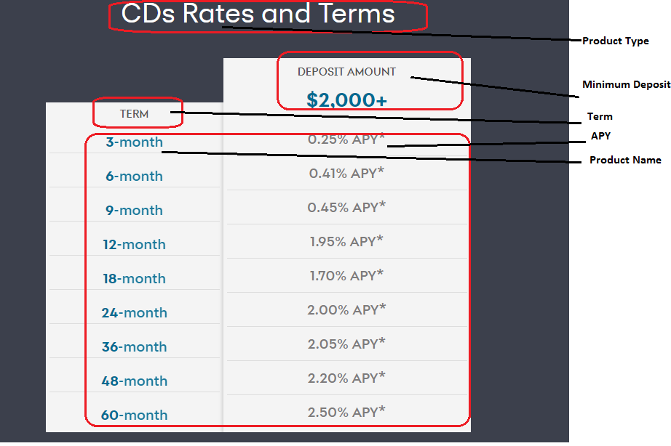

Money Market

**URL:** <https://www.synchronybank.com/banking/money-market-account/>

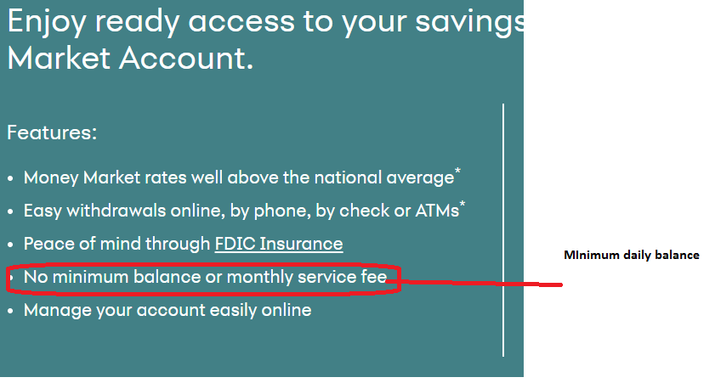

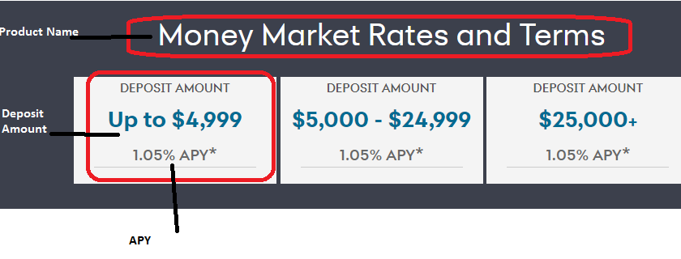

High Yield Savings

**URL:** <https://www.synchronybank.com/banking/high-yield-savings/>

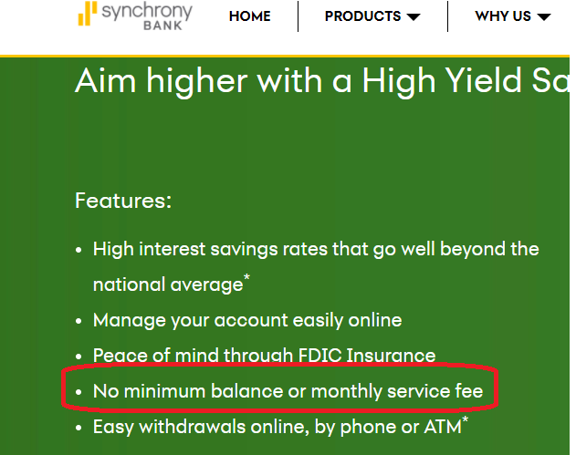

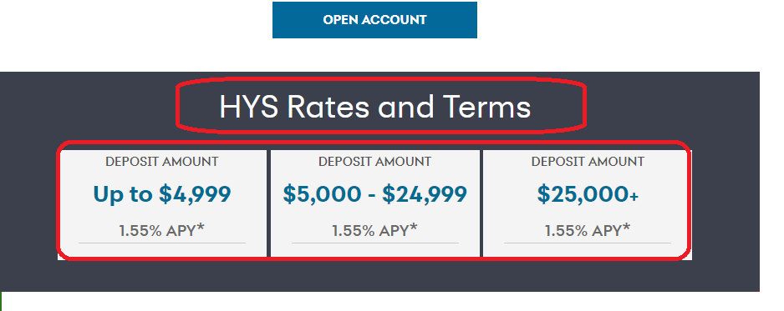

No Mortgage rates are available